Optimization techniques on simple GA
Muneeb Usman & 14039123

1 INTRODUCTION

In this assignment we solved three functions, The first one is based on a single variable and the rest two are based on two variables. The limits are given on which the function is defined. We can see f(x) on the left side and a mathematical expression on the right side. Function of x or f(x) can be retrieved by solving the expression given on the right hand side. Simply you can say that f(x) is the range and ‘x’ is the domain. There are a lot of algorithms which are based upon the natural phenomenon like P and O, PSO, GA and ACO. The best optimization technique to solve these type of expressions is the Genetic Algorithm. This algorithm is based upon the natural selection and mutation which is in accordance with the Darwin theory of evolution. In this algorithm the first step is to identify the population. The population is also called as the sample space in which all the elements or members are there. First there is selection of the best candidates within this population. These candidates are called as the parents with best characteristics. Now as in biological sciences there is mating between the parents to create off springs. The thing which is responsible for the creation of new characteristics or best offspring’s are called as chromosomes.

2 BACKGROUND RESEARCH

The local research method for finding approximate alternatives to search optimizations and issues is a genetic algorithm (GA).

Genetic algorithms are a class of evolutionary algorithms that employ evolutionary biology-inspired methods such as inheritance, mutation, choice and crossover (also known as recombination).

3 EXPERIMENTATION

Now we have the main equation of the function. This is called as the transfer function. In order to have an output we must put a numerical value to the transfer function. Numerical value must lies within the range given along with function. After putting some values we extracted outputs from the functions. In our coding algorithm we made an edit box in which we placed all our values we got from transfer function. As we are using MATLAB platform so the values are in matrices. The next step is to add all the values to get a sum. In next step the sum is divided upon the number of values to get an average value. The second edit box is showing the binary encoded results we got from the transfer function. The values now looks like ‘1001100’ seven bit binary number. The one seven bit value is also called as the chromosome. We then selected two parents from this population. The selection criteria is based on the highest decimal numbers we got in the first edit box. After the declaration of parents, the next step is to cross over the genes. Now the one bit in the whole number represents a gene. We can select randomly two bits from each chromosome and do change them with each other. After the crossing over we can do the next step and that is called as the mutation. In natural processes the mutation is very common. In this process any gene can be altered like can be made as ‘0’ and can be declared as ‘1’. After these processes one more thing we did is to find the expected count of the population. All the population decimal values are divided by the average value we got and it gave us the expected count. After this we found the Roulettes wheeling by rounding off the expected count matrix. This tells us that which chromosome is more likely to show its effect. After all the steps are applied again we computed the sum of the population and we got an increase, after applying again and again this technique we got the best values. Apart from sum, p select I, expected count also increased. As we used MATLAB to perform all this there

is a GUI(Graphical User Interface) which is tied with the back end coding to give us a better visualization.

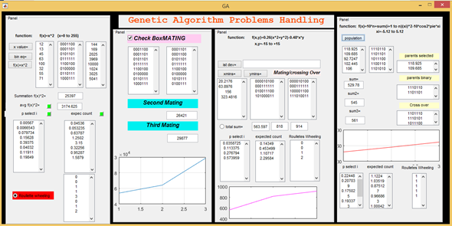

Figure1
In this GUI we used a lot of components like push buttons, static texts, edit text boxes, Axes, radio Buttons, panels and check boxes. In GUI there are four main panels. The first two panels are for first function and the rest two are for the next two functions. Edit boxes are made as multiple lines from property inspector as we have multiple values. All values are arranged as the column matrices. For first function we got an increase in the sum function which showed that we applied the algorithm in the right direction. As we press a specific button or any element in GUI the control goes from the element to its call back function and it is executed then. Let’s take a look at the following figure.

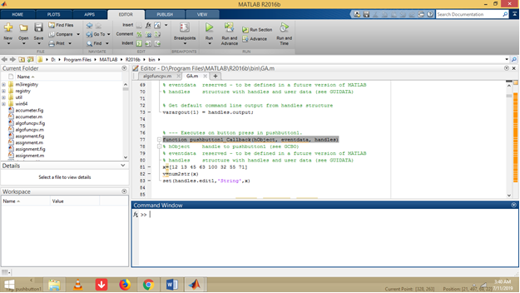

Code for Population generation
This is the code for push button1. First population is created randomly with no biasness involved. Then in order to convert it into string data type and then store it in the variable declared as ‘v’, After it the command set(handles.edit1,’String’,x) send the data to be shown on edit box1.

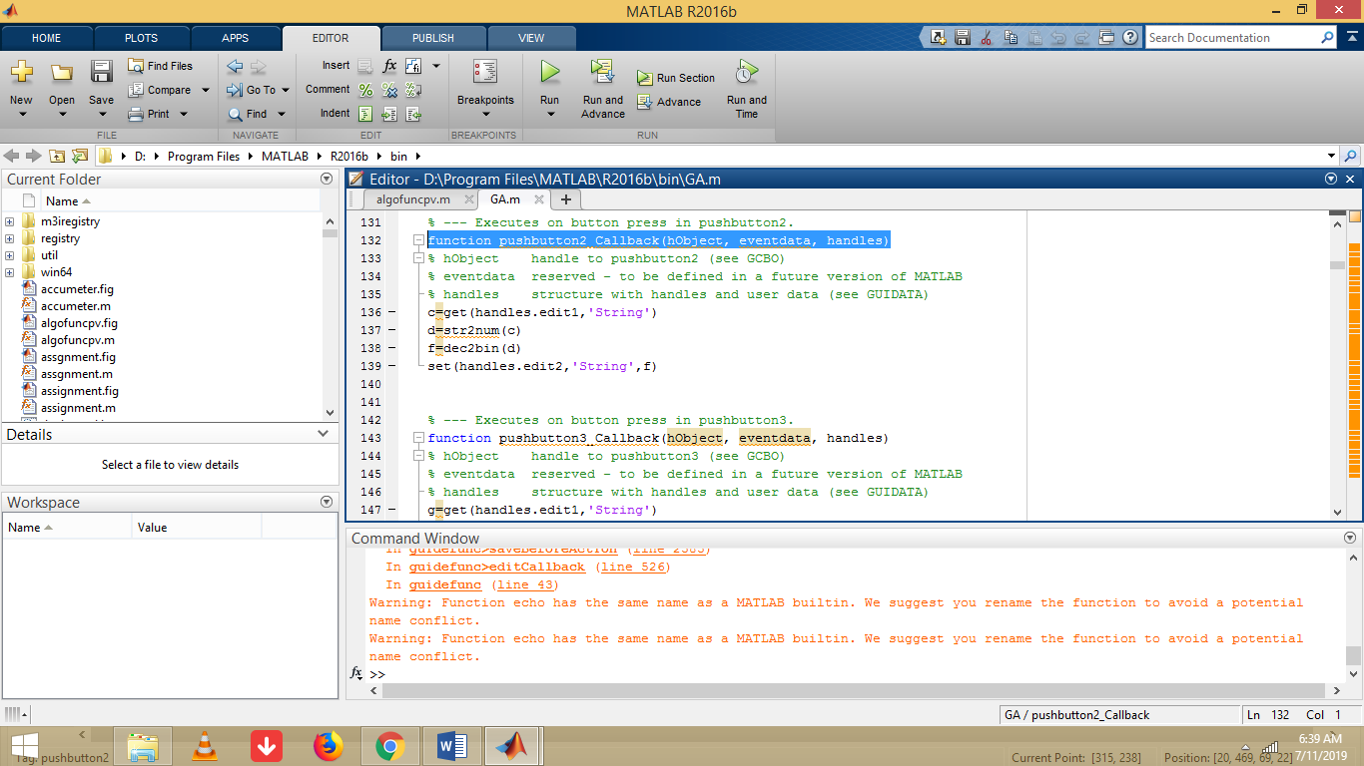

Binary Encoding

The second push button’s call back function is shown in the figure. This function is taking data from edit1 edit boxes and then converts it into the numerical type which can be called as integer type.
After converting it to the decimal format then the conversion from decimal to binary taken place. After it the data is sent to the edit2 box to be shown in GUI.

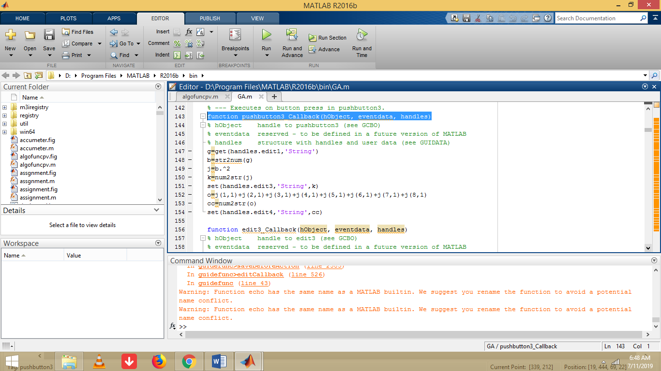

Objective Function Implementation
This piece of code is showing the data taken from the edit1 box and then its conversion from ‘String’ data type to numerical (integer) format. In this piece of code the objective function is implemented on every member of the population or we can say that on every element of column matrix. The command
‘j=b.^2’ gives us the solution matrix based upon the objective function i.e. f(x)=x2. The data is extracted from the variable j by applying the commands ‘o=j(1,1)+j(2,1)…’. Then the data is converted again to the String data type and send it to the editbox4.

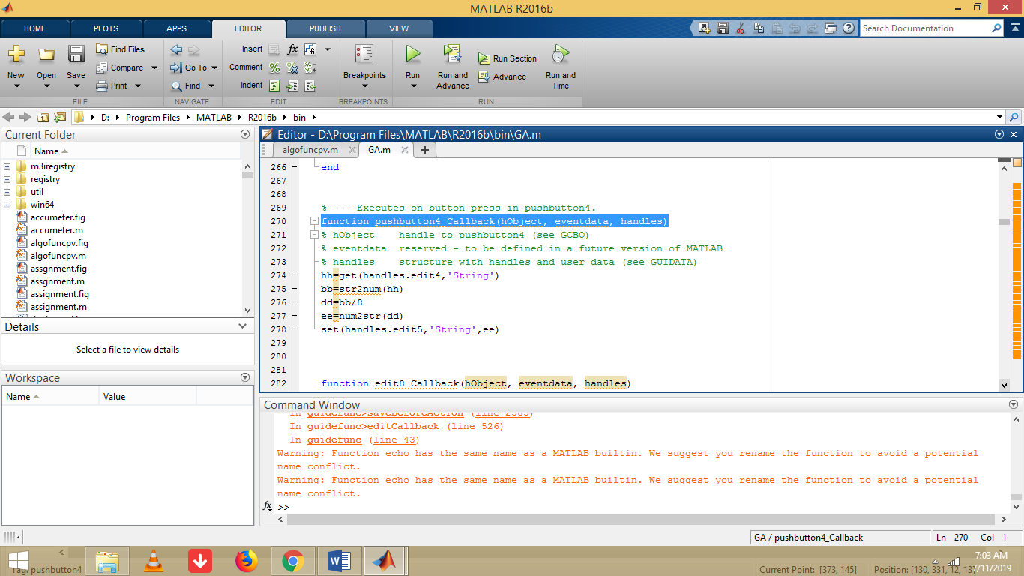

Average value extraction
In the call back function of pushbutton4 we are getting data from edit4 edit box and then convert it to the numerical form. Then the sum of data is divided by the population number to get the average value.

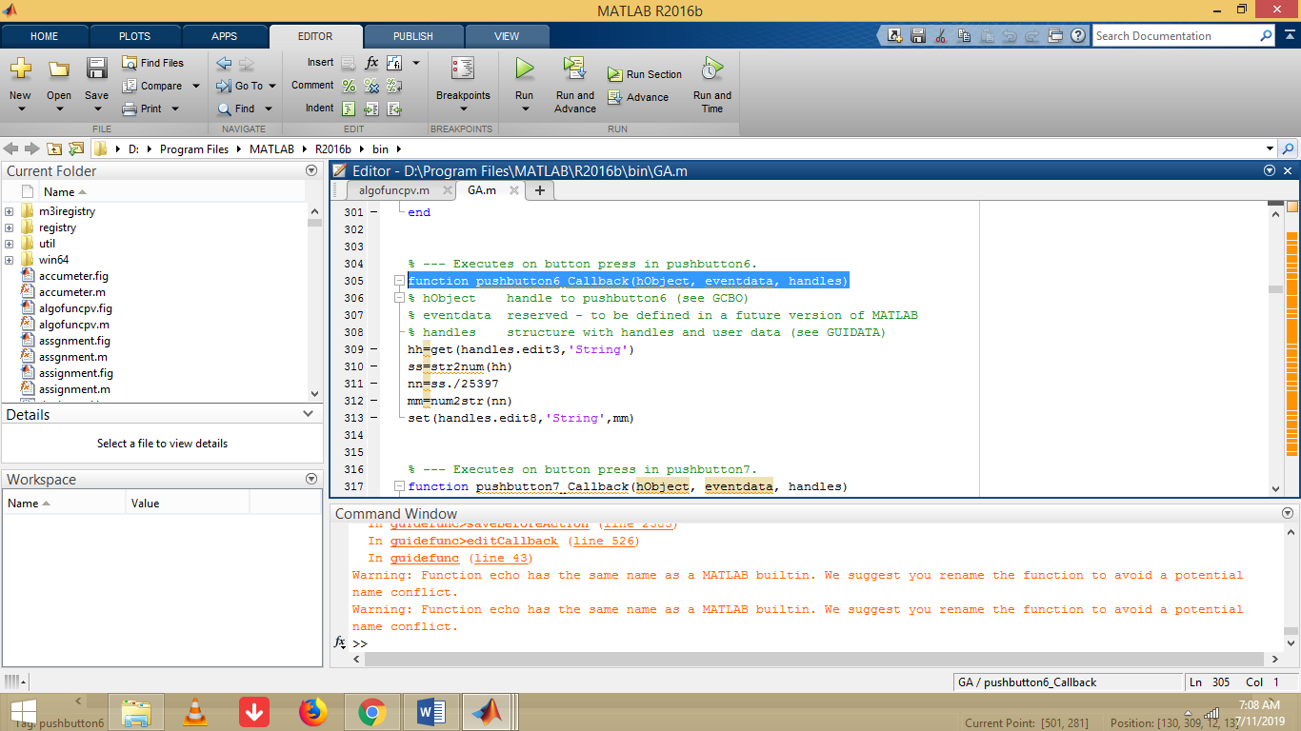

The value of p select i can be calculated by dividing the values of the population by the sum.

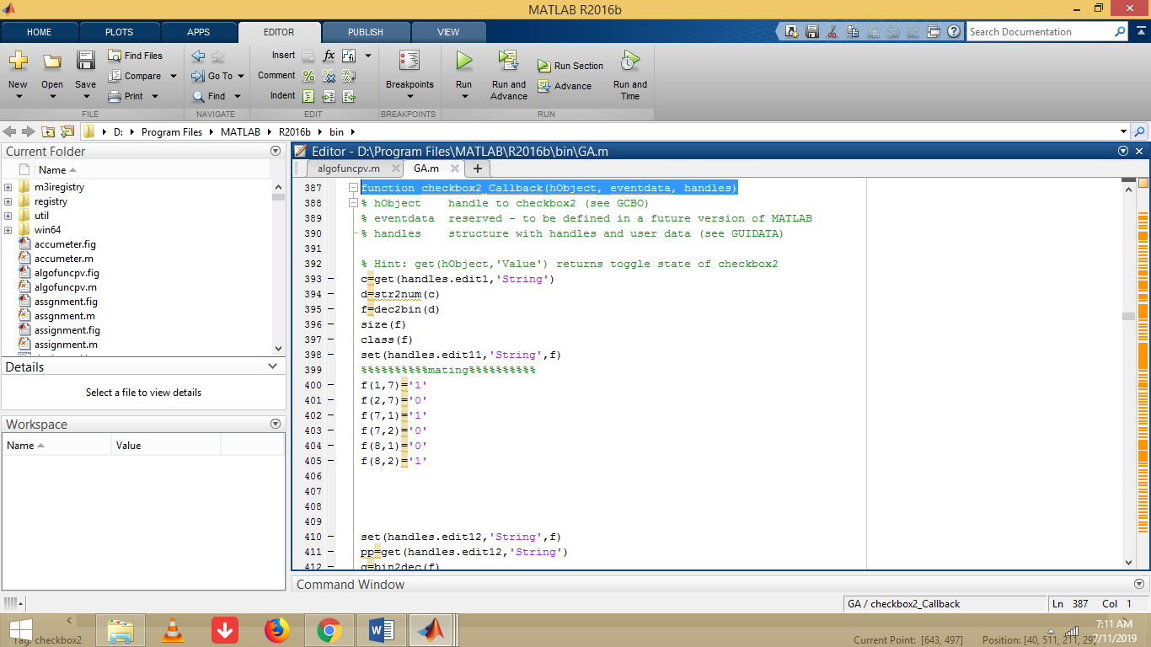

Crossing Over and Mutation
In this section of the code the cross over is done within the parents to get the best results. After crossing over the mutation is applied and then we calculates the ‘sum’ and ‘p select i’ and ‘expected count values’. All of them increased. The increase in the values of results of the ‘sum’ can be shown in graph. T

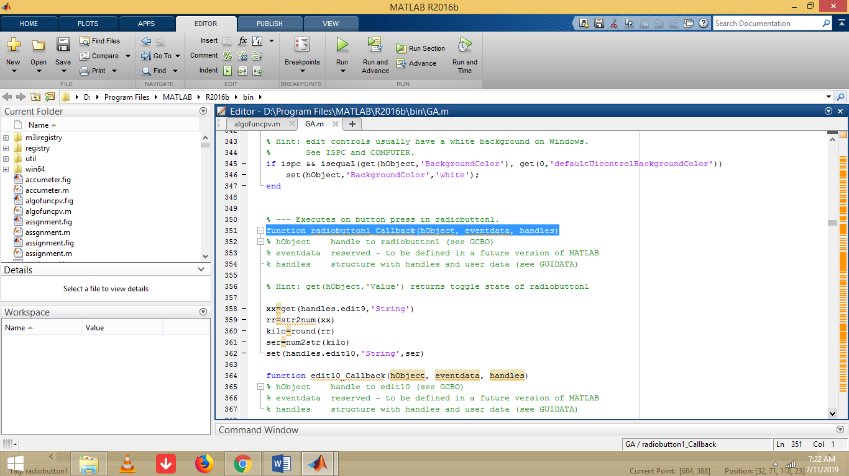
Roulettes Wheeling
The values in the expected count edit box are round up to get the Roulettes Wheeling. The command ‘round (rr)’ is used for the rounding off the data.

4 CONCLUSIONS

After extraction of the values of sum from the population we can see an increase in the values and is also shown in graphs. Thus GA is a better optimization technique for solving problems based on specific objective functions.

REFERENCES
Evtushenko, Y.G. and Stoer, J., 1985. Numerical optimization techniques. Optimization Software, Incorporated, Publications Division.

Sivanandam, S.N. and Deepa, S.N., 2008. Genetic algorithms. In Introduction to genetic algorithms (pp. 15-37). Springer, Berlin, Heidelberg.

And please include either a link to your source code so that more than one person can access it over the next few months or as a full listing in an Appendix. The second marker and external examiner need to be able to see what you actually produced.

